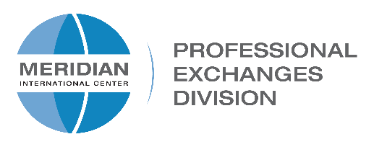
Meridian International Center • 1624 Crescent Place, NW • Washington DC 20009

APPLICATION FOR MERIDIAN/CBM STAFF EXCHANGE
for hosting Meridian Staff

The exchange is an opportunity for Meridian Staff to gain a greater understanding of the workload and challenges at a CBM. Meetings and site visits will focus on management and programming best practices.

Please fill out this form if you are interested in hosting a Meridian staff member
and submit for approval to PEDstaffexchange@meridian.org by Friday, February 14, 2020.

CBM:

Contact Person:

Website:

Office Phone:

Cell:

Email:

- Describe your interest in hosting a Meridian International Center staff member:

- Would it be possible to provide housing and transportation for a visiting Meridian staff member? If there are anticipated program-related costs, please mention them below:

- What meetings could you arrange to discuss management topics, such as budgeting, proposal writing, programming best practices, and any other topics of interest?

- Should your CBM be selected to participate in the Staff Exchange program, please check which of the following weeks you would prefer:

Week of:
April 20 – 24, 2020: | ☐ | June 1 – 5, 2020: | ☐
April 27 – May 1, 2020: | ☐ | June 8 – 12, 2020: | ☐
May 4 – 8, 2020: | ☐ | June 15 – 19, 2020: | ☐
May 11 – 15 2020: | ☐ | June 22 - 26, 2020: | ☐
May 18 – 22, 2020: | ☐ | June 29 - July 3, 2020: | ☐
 |  | Other: ___________________ | ☐

Name (print):____________________________________ Date: _______________

Signature: ______________________________________ Date: ______________

Supervisor Signature: _____________________________ Date:_______________

