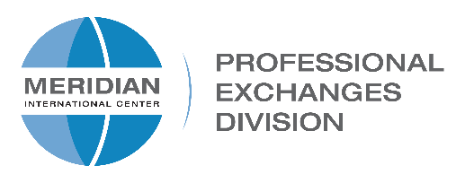
Meridian International Center • 1624 Crescent Place, NW • Washington DC 20009

APPLICATION FOR MERIDIAN/CBM STAFF EXCHANGE
for CBM Staff
Please fill out this form if you are interested in making a professional visit to Meridian International Center and submit for approval to PEDstaffexchange@meridian.org by Friday, February 14, 2020.
Note: You must have worked at your CBM for at least one year.

Name:

Position:

CBM:

Website:

Office Phone:

Cell:

Email:

- How long have you been working in the Global Ties network?

- How many IVLP projects and visitors does your CBM receive each year?

- Please provide a brief description of your current job responsibilities.

- What would you hope to accomplish during your visit to Meridian?

- How would you apply your experience in Washington and share it upon your return?

- Please check the following weeks you would be available if chosen for the exchange (you can check more than one):
Week of:
April 20 – 24, 2020: | ☐ | June 1 – 5, 2020: | ☐
April 27 – May 1, 2020: | ☐ | June 8 – 12, 2020: | ☐
May 4 – 8, 2020: | ☐ | June 15 – 19, 2020: | ☐
May 11 – 15 2020: | ☐ | June 22 - 26, 2020: | ☐
May 18 – 22, 2020: | ☐ | June 29 - July 3, 2020: | ☐
 |  | Other: _________________ | ☐

I understand that Meridian will cover the cost of airfare, meals and ground transportation in DC and will provide a homestay or other accommodations. I will be responsible for any additional expenses. I will submit a written report within one month of completing the exchange, sharing lessons learned and the value of my exchange experience.

In making this application, I have the full support of my supervisor and/or Board of Trustees.

Name (print):____________________________________ Date:_______________

Signature: ______________________________________ Date:_______________

Supervisor Signature: _____________________________ Date:_______________

